**City of Los Angeles**

**Homeless Analysis Report**

DSO 545 Final Project - Fall 2017

*Group 13:*

*Keying (Claire) Que*

*Yu (Yolanda) Luo*

*Lantian (Laura) Qin*

*Ruoxian Jia*

*Olivia Huang*

*Yue Shi*

**Executive Summary**

Challenge

Homelessness is one of the biggest challenges faced by Los Angeles County. The total number of homeless population has soared over 23 percent in the past year, reaching 58,000. Although the measure HHH has passed, dedicating $1.2 billion funding in bonds to combat homeless, resource is still limited. Moreover, people become homeless for various reasons. Some of them suffer from domestic violence or loss of a significant other; some want to pursue their dreams and move to Los Angeles, but realize the housing price is too high for them to afford. Because diversity exists in the homeless population, we need to provide unique support to different subgroups, instead of having one strategy fits all. All of these are current challenges that the City is facing, and it is necessary to allocate resources properly and strategically and serve areas in the most needs.

Objective

To support the Mayor’s goal of reducing homelessness in the City of Los Angeles by 50 percent, we set our goals to 1) identify vulnerable homeless population subgroups; 2) provide actionable recommendations to allocate resources for these vulnerable subgroups; 3) introduce an interactive dashboard for a holistic overview of situation changes over time.

Methodology and Insights

First, we conducted primary analysis on each of the datasets provided by the City of Los Angeles and with some additional research to understand homeless situation based on community, safety, density, and time change. Since the youth homeless population has grown over 60 percent in the past year, we chose to look into the youth subgroup as one of our focuses. In addition, we found that females and males are victims of different crimes, motivating us to draw more analysis on gender differences. Based on further analysis, we identified that female and youth are the most vulnerable subgroups of homeless population.

Recommendations

We recommend that the City of Los Angeles sets priorities to support youth homeless (age 18 - 24) to become independent and offer females homeless the priority for shelters and housing arrangement. For youth who became homeless due to lack of secure income to afford their rent, we recommend that the city provide pre-employment training and job placement support by partnering with local non-profit organizations. Youth coming out from foster care at age 18 also composes a part of youth homeless population. Therefore, we recommend that the city first identify this specific segment of youth, then work with Living Advantage, Inc. and The Alliance for Children’s Rights to provide transportation, academic classes and workshops to support their continuous growth. Last but not least, providing priority shelter, housing assignment, and mental health support for females are important to ensure that they have safe places and healthy minds to continue living their lives.

**Dataset Description**

311_calls_w_CTs20171102134828.csv (311 Calls)

* 311 request calls for homeless encampment from January 2017 to November 2017, including request source, address and status

HC2016_Total_Counts_by_Census_Tract_LA_CoC_07132016.xlsx (Homeless Count 2016)

* Total homeless count in LA County by census tracts in 2016, including counts of homeless people in different age groups, different types of places or shelters.

Homeless-count-2017-results-by-census-tract.xlsx (Homeless Count 2017)

* Total homeless count in LA County by census tracts in 2017, including counts of homeless people in different age groups, different types of places or shelters.

shelters_w_CTs20171102103122.csv (Shelters)

* A list of homeless shelters in LA, including name, location, hours, description and contact information.

**Analysis on Homeless Count Dataset**

The Homeless Count dataset included information from both 2016 and 2017. We analyzed this dataset to better understand the different segments of the homeless population, the shelter spread within each homeless population, and which communities have the top homeless count in Los Angeles County. We created visualizations for both 2016 and 2017 to make better comparisons and pinpoint trends over the past two years.

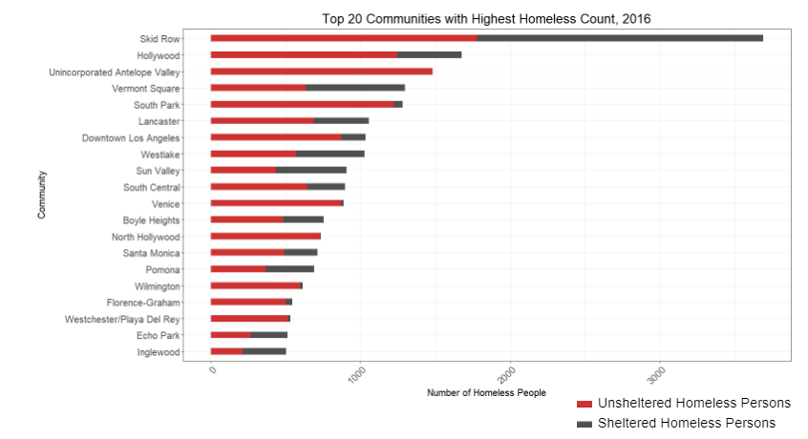



In this graph, we plotted the top 20 communities in 2016 with the highest total homeless count. The dark red represents the total unsheltered homeless persons within each community while the grey shows the count of sheltered homeless persons. This graph shows the proportion of unsheltered homeless persons for each community. It is important to note that while Skid Row has the highest total homeless count, it has one of the lowest proportions of unsheltered homeless persons.

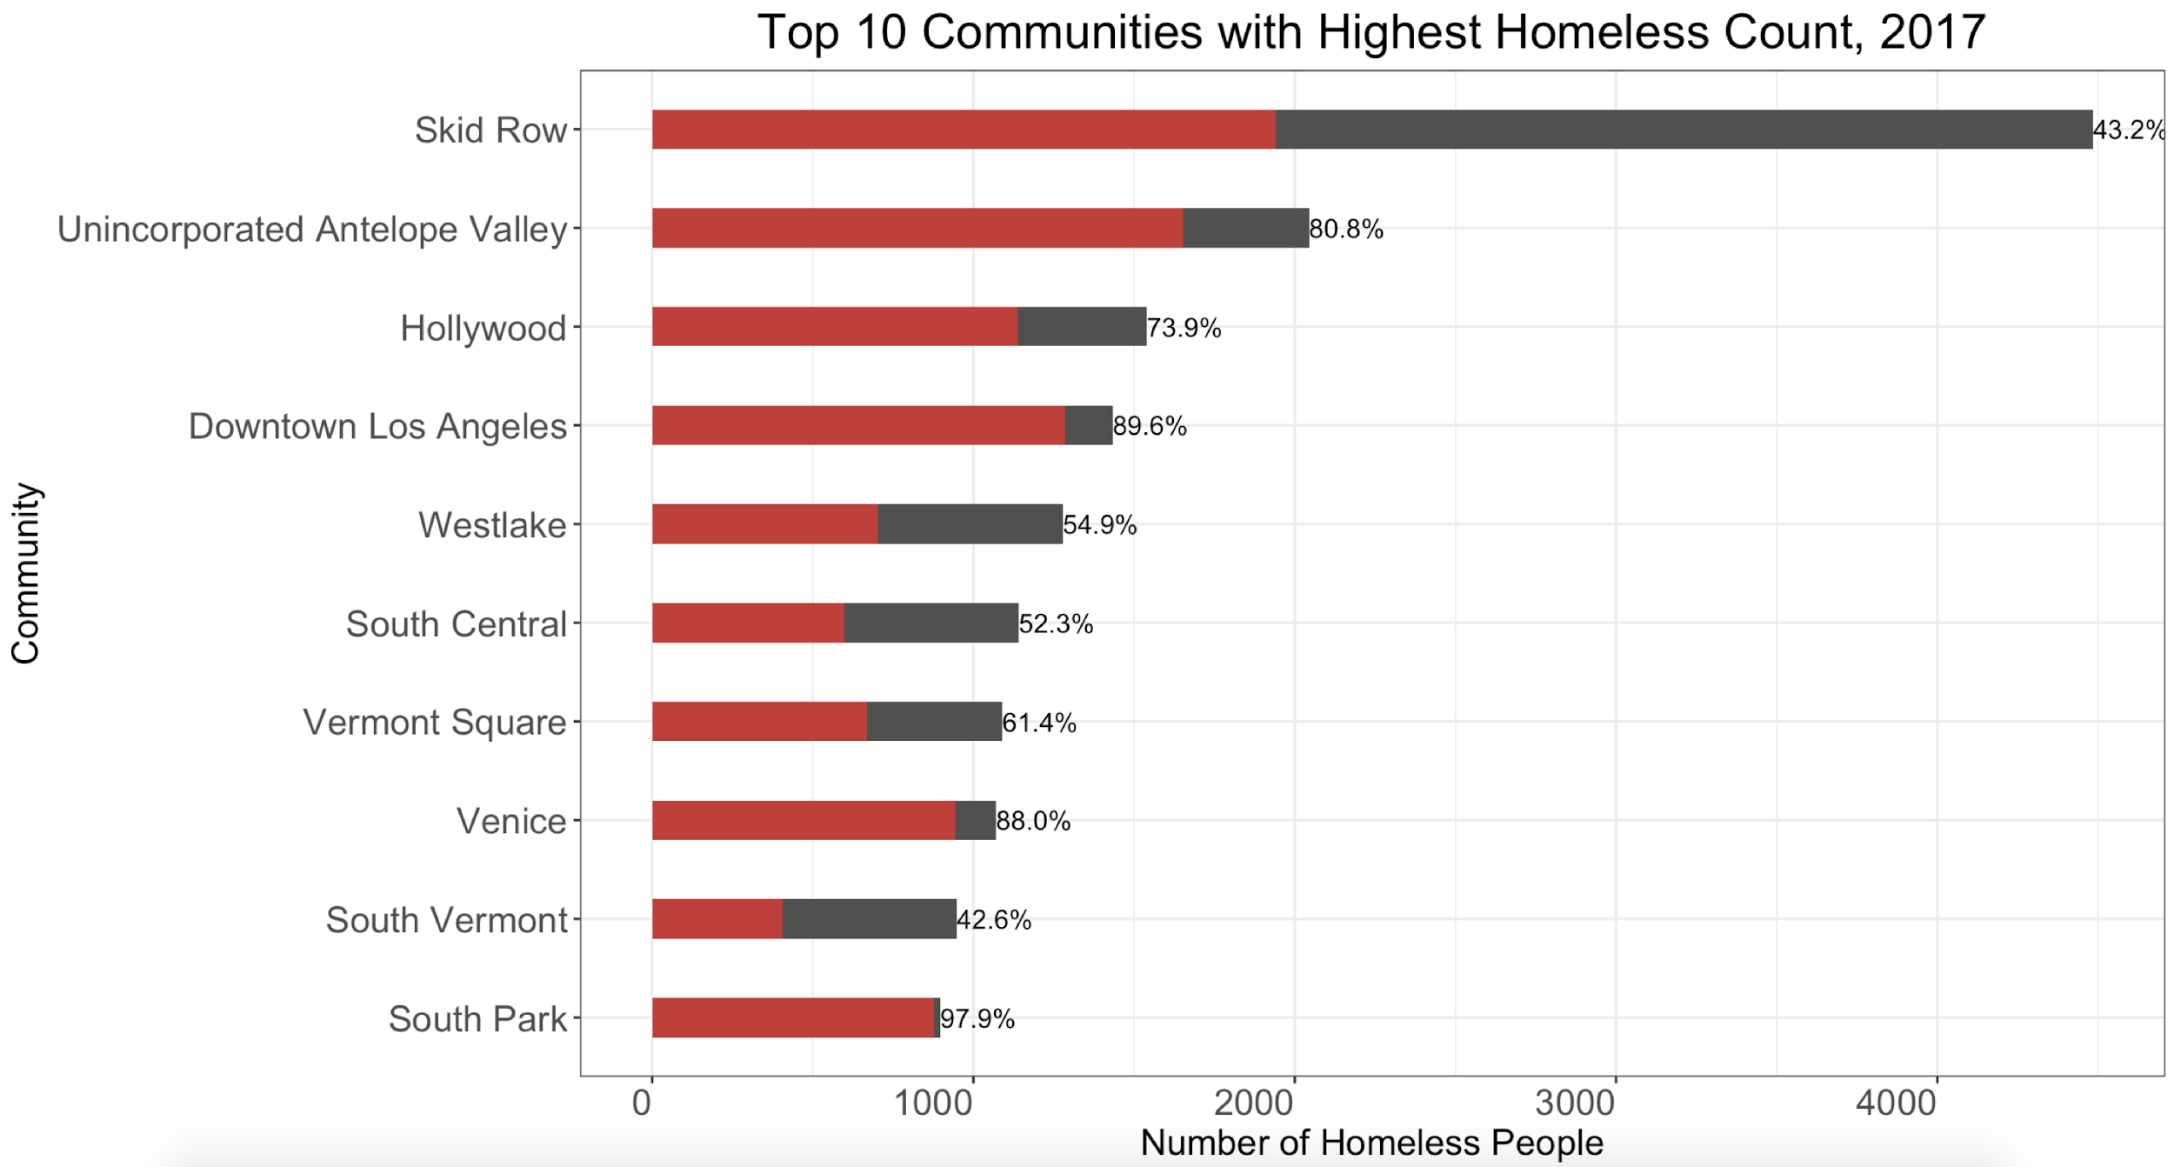



Similarly, this graph shows the percentages of unsheltered homeless persons in the top 10 communities for 2017. By far, South Park has the highest proportion of unsheltered homeless persons, with 97.9%.

Just looking at the top 10 communities for both years, we can see that Skid Row remains at the top with the highest homeless count of all communities. From 2016 to 2017, several communities changed; Westlake, South Central, Venice were in the top 10 for 2017, but were not for 2016. This indicates that the homeless count and the rate of growth and decrease in that count is not consistent among all the communities.

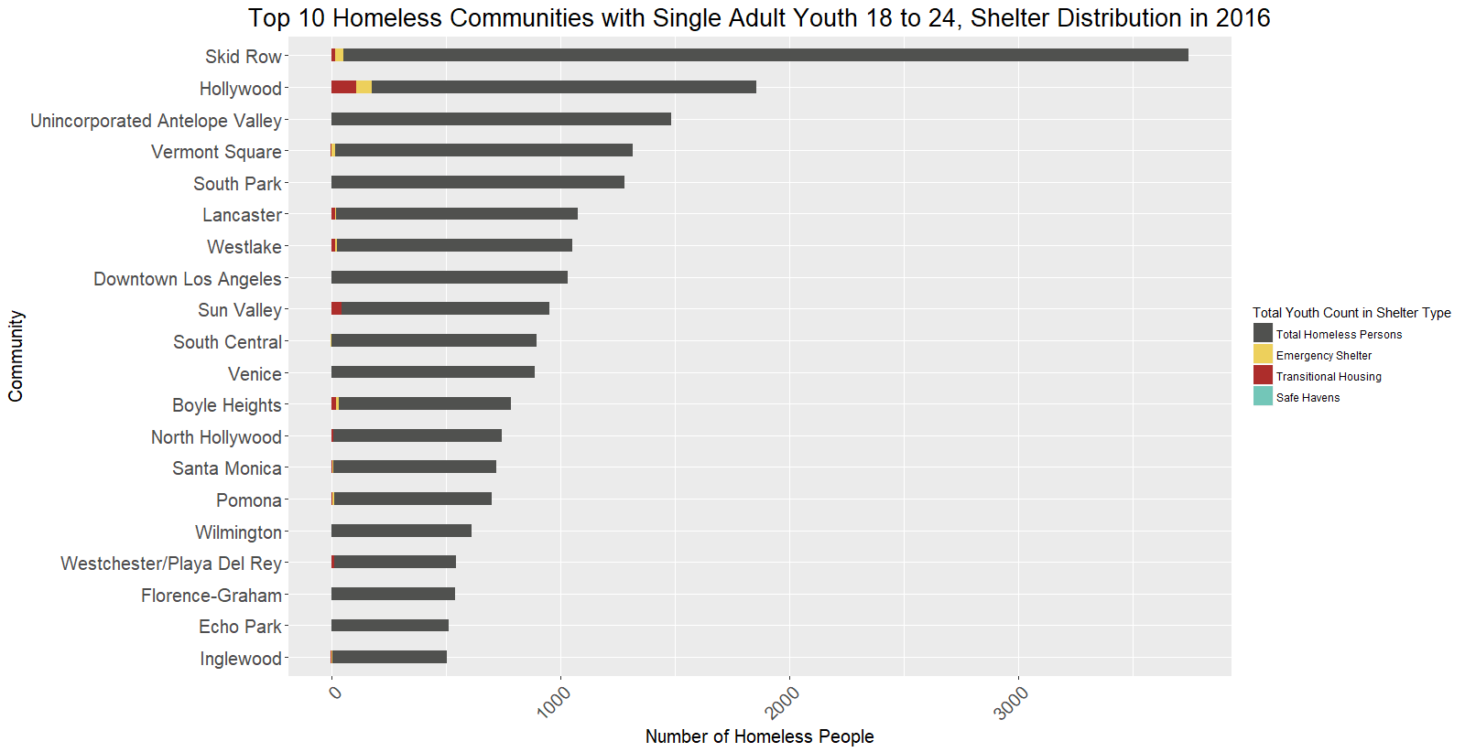

The focus of our presentation was on the youth homeless population, from ages 18 to 24. To better understand the current shelter situation among these homeless youth, we created this graph showing the spread of homeless youth in the different shelter types, including emergency shelter, transitional housing, and safe havens. From this graph, we find that there are the most sheltered youth in Hollywood and Skid Row in 2016 and that overall, a shockingly large proportion of homeless youth in Los Angeles County are unsheltered.

Together, these findings helped us pinpoint critical communities and segments of the homeless population to better focus our homeless intervention strategies.

**Analysis on 311 Call Dataset**

We did some exploratory analysis on 311 calls data, and came up with some visualizations that show the trends and distributions of 311 calls that are made for homeless encampment. Although we decided not to include analysis on 311 calls in our final presentation to keep our content consistent, there are some interesting discoveries that come with this dataset that are worth noticing and could potentially be useful.

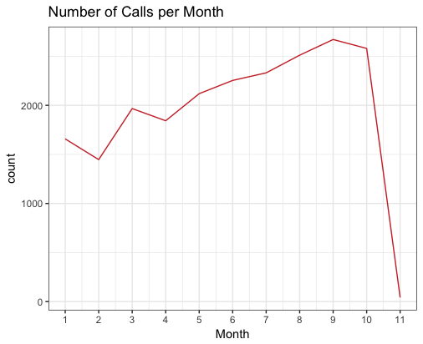

This graph shows the total number of calls made per month in 2017. Since the data for November is not complete by the time we got the data, the sharp decline from October to November can be disregarded. Overall, it seems that throughout the year the number of 311 calls has been increasing steadily. This could either be due to increasing number of homeless people, or people becoming more aware of the 311 calls service.

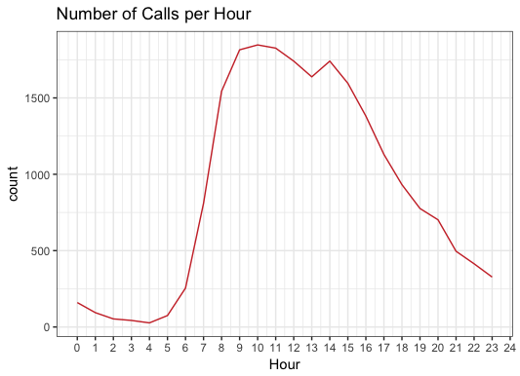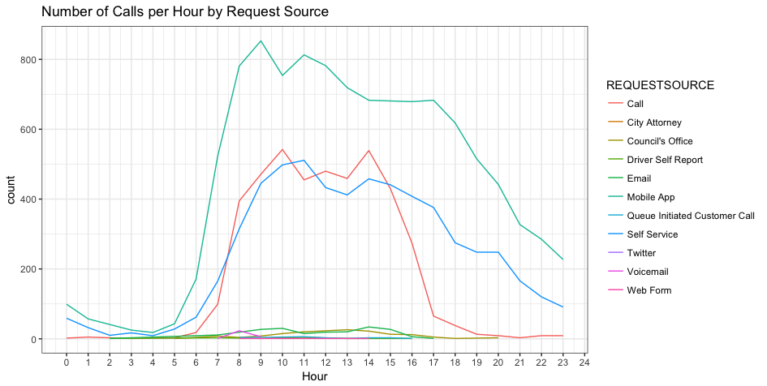

The left graph shows the total number of 311 calls received per hour, which shows a cyclical pattern. The Mayor’s office receives least amount of calls from 12am to 5am, then the number of calls increases quickly to its highest point of the day at 10 am. Then the number gradually declines to the previous level at midnight.

The right graph shows the number of 311 calls per hour, separated by request source. As seen on the graph, the 3 most popular request sources are mobile app, self service and calls. While the usage of mobile apps follows the same pattern as the graph for the total number of calls, the number of self service 311 requests seems to decline more slowly after the peak, whereas the number of phone calls declines quickly from over 500 to less than 100 from 2 pm to 5 pm.

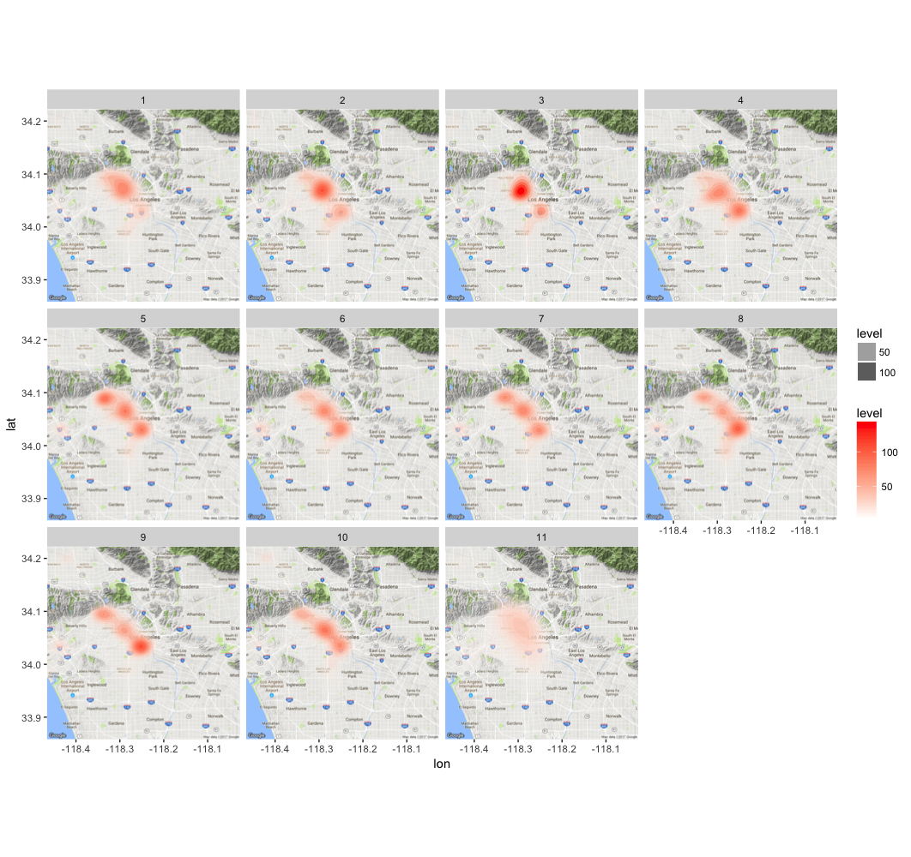

The graph shows the change in distribution of 311 calls over the course of the year, each small square shows the choropleth graph of that month’s 311 requests. Comparing the graphs, we see that from January to March the distribution of calls concentrates towards south Hollywood, and from April to June the distribution dispersed. From July to September, the distribution starts to concentrate again towards downtown.

**Analysis on Crime Dataset**

Gender

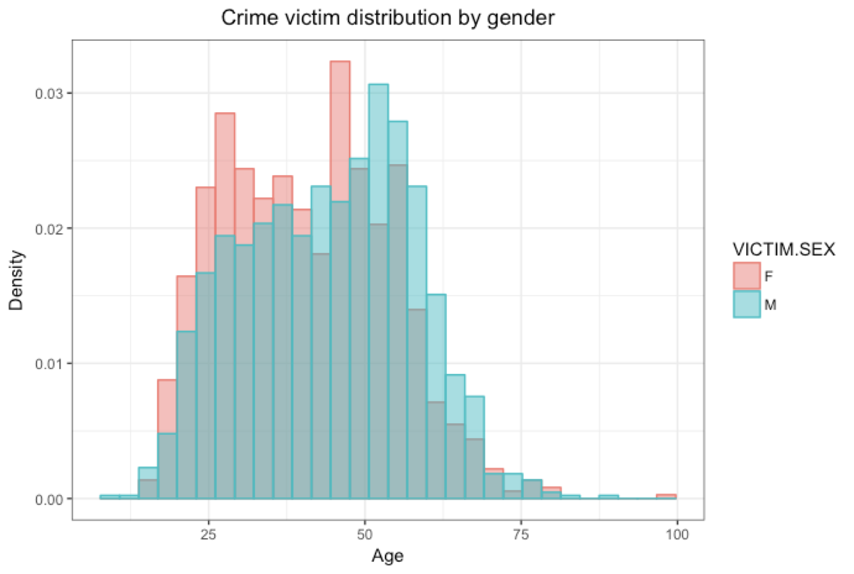

We first looked at the overall distribution on the gender of crime victims. More female homeless around age 18 to 40 are victims of crime, whereas more males over 50 years old are victims of crime comparing to that of females.

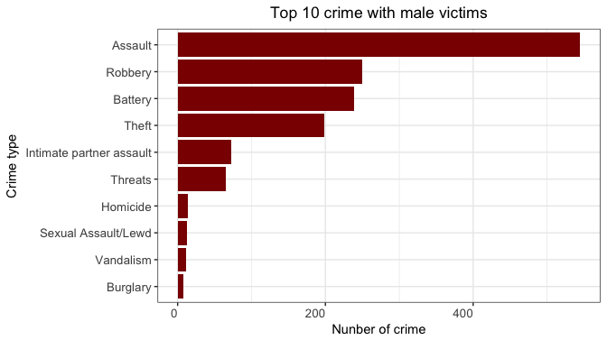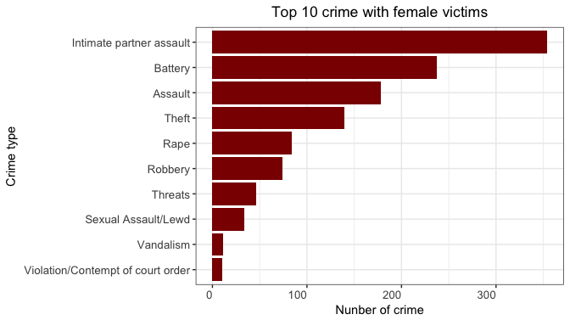

When we further analyzed what type of crimes from which females and males suffer, we found that females are more vulnerable towards a unique set of crimes, such as intimate partner assault and rape. Although sexual assault happens relatively often on both females and males, female homeless are the majority of victims.

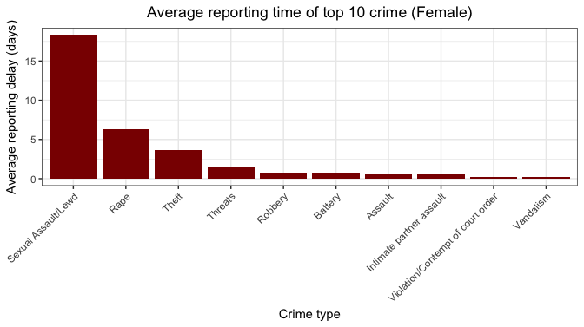

Previous findings drew our curiosity and focus towards female homeless population even further. We calculated number of days between the date of each crime occurred and the date of the crime reported, as a new valuable called reporting delay. After computing average days of reporting delay for each type of crimes female, we found that females generally wait much longer to report sexual assault and rape. The average days of delay for sexual assault is 18 days and that of rape is 6 days, comparing to less then one day of reporting delay for most of the other crimes. One main reason could be that females are not as comfortable sharing and reporting crimes that physically and emotionally harm the body. Further, it may take some time for them to process and recognize the reality of the situation at hand, indicating the importance of increasing mental health support and instigating preventative measures.

Youth

**Total Homeless Population by Age, 2016-2017**

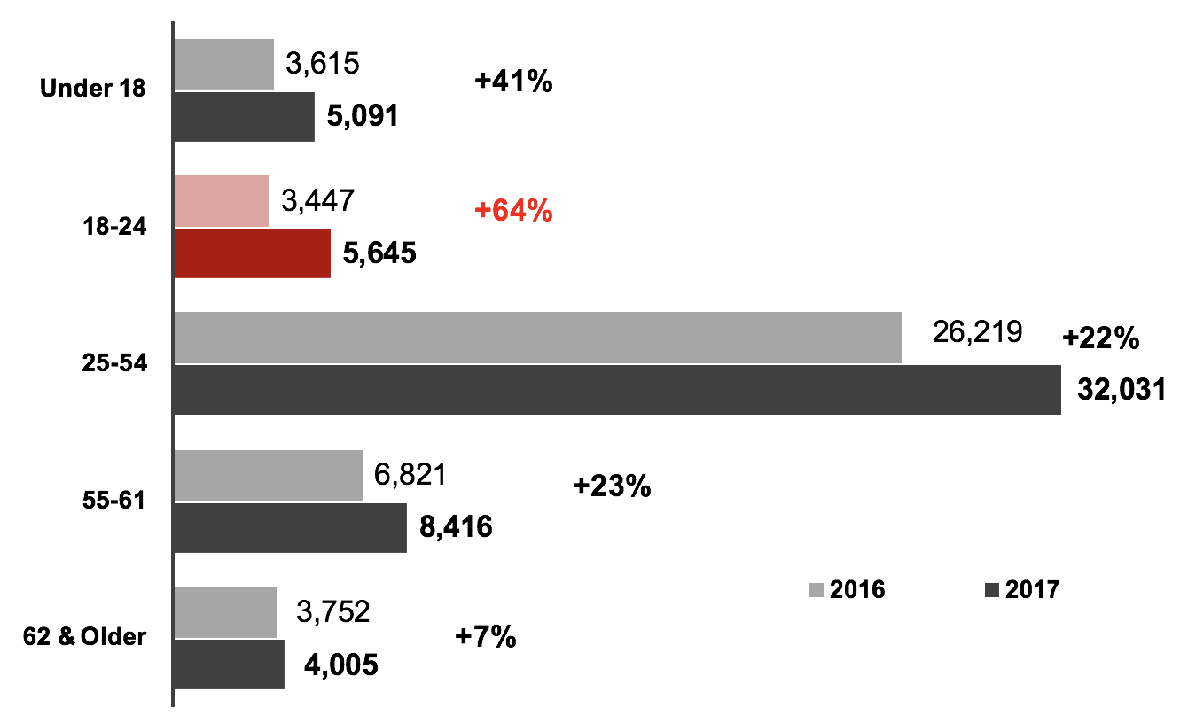

Why do we want to focus on youth? According to 2017 Homeless Count Results by LAHSA, although the majority of homeless people are in age 25 to 54, homeless population in the 18-24 age group increased the most at 64%, followed by the homeless under age 18. Since youth will grow up to middle-aged people, if we take action to control the surge of youth homelessness,s would help decrease the count of the majority age group in the long run.

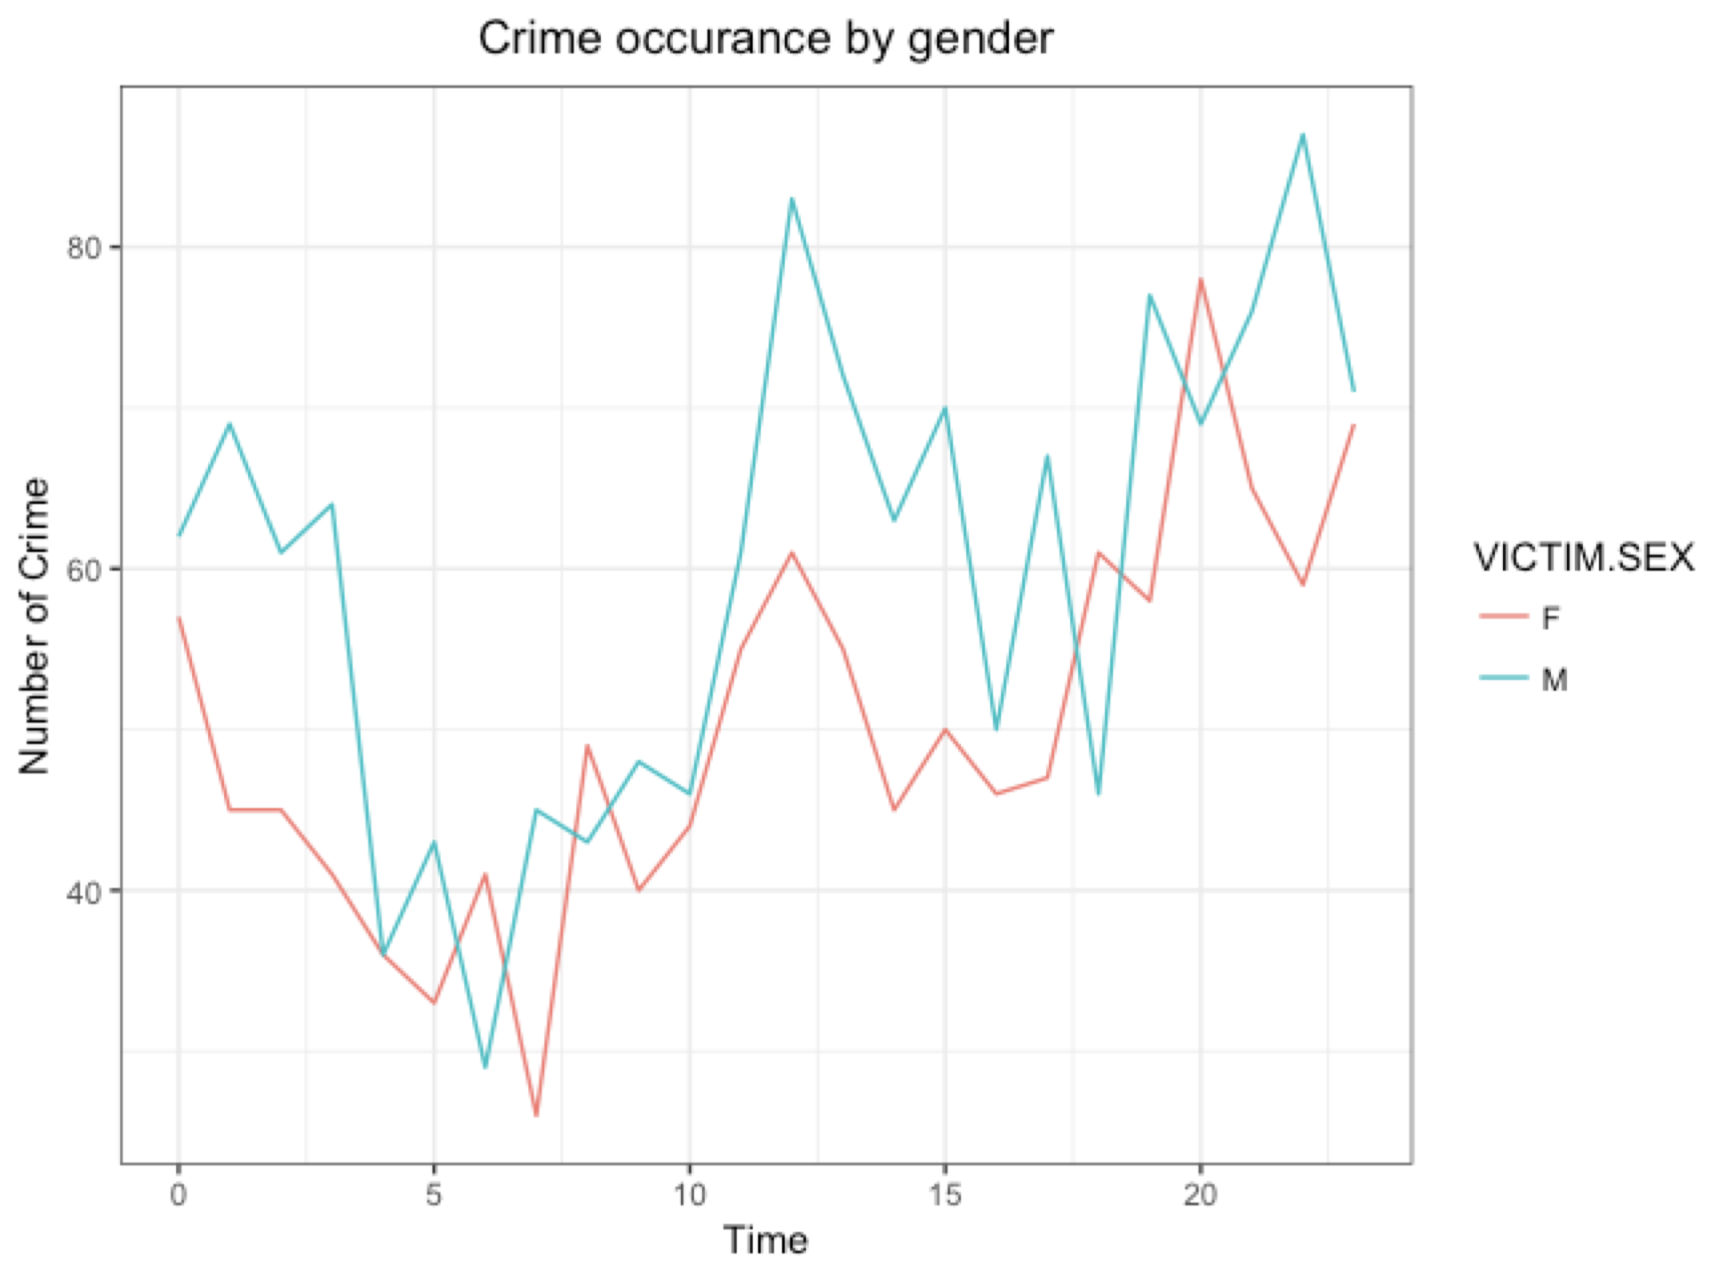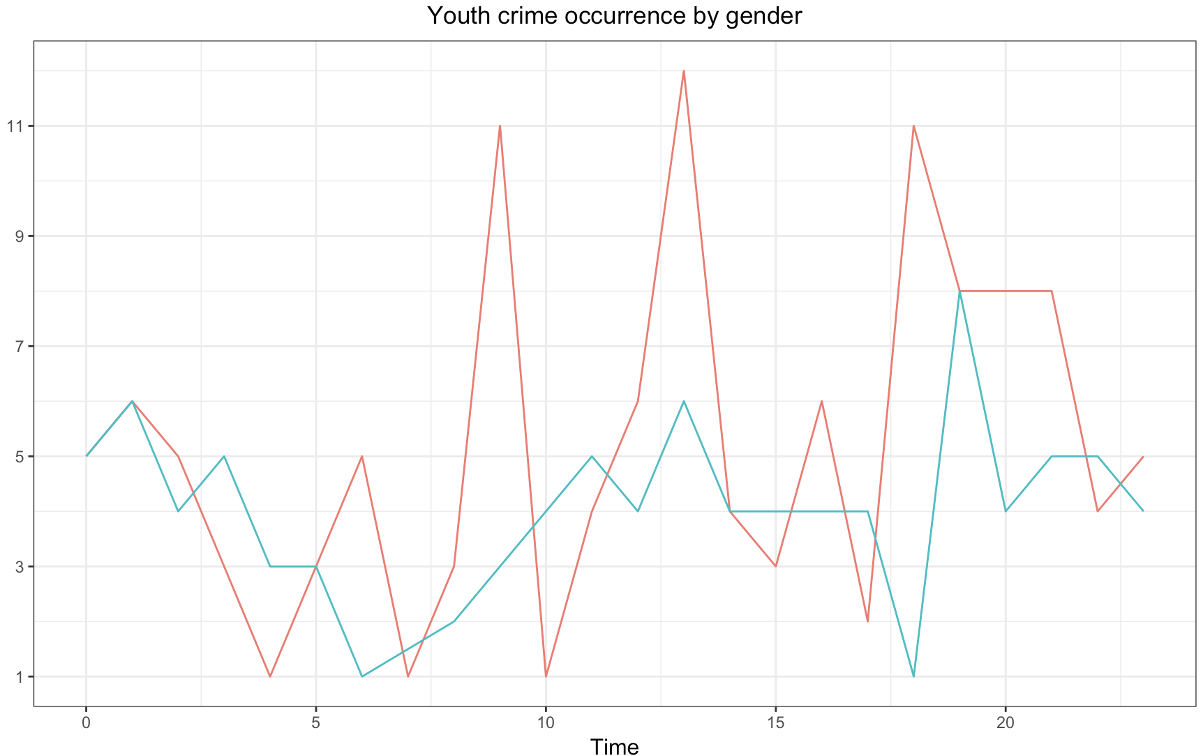

Among all homeless victims, the majority of them are male. That makes sense because total population of male homeless people is more than female. 68% of homeless people are male in 2017. However, when take the subgroup of youth, pink line is above the blue line, that is to say, more youth victims are females. Therefore, young females are a vulnerable group we should pay more attention to.

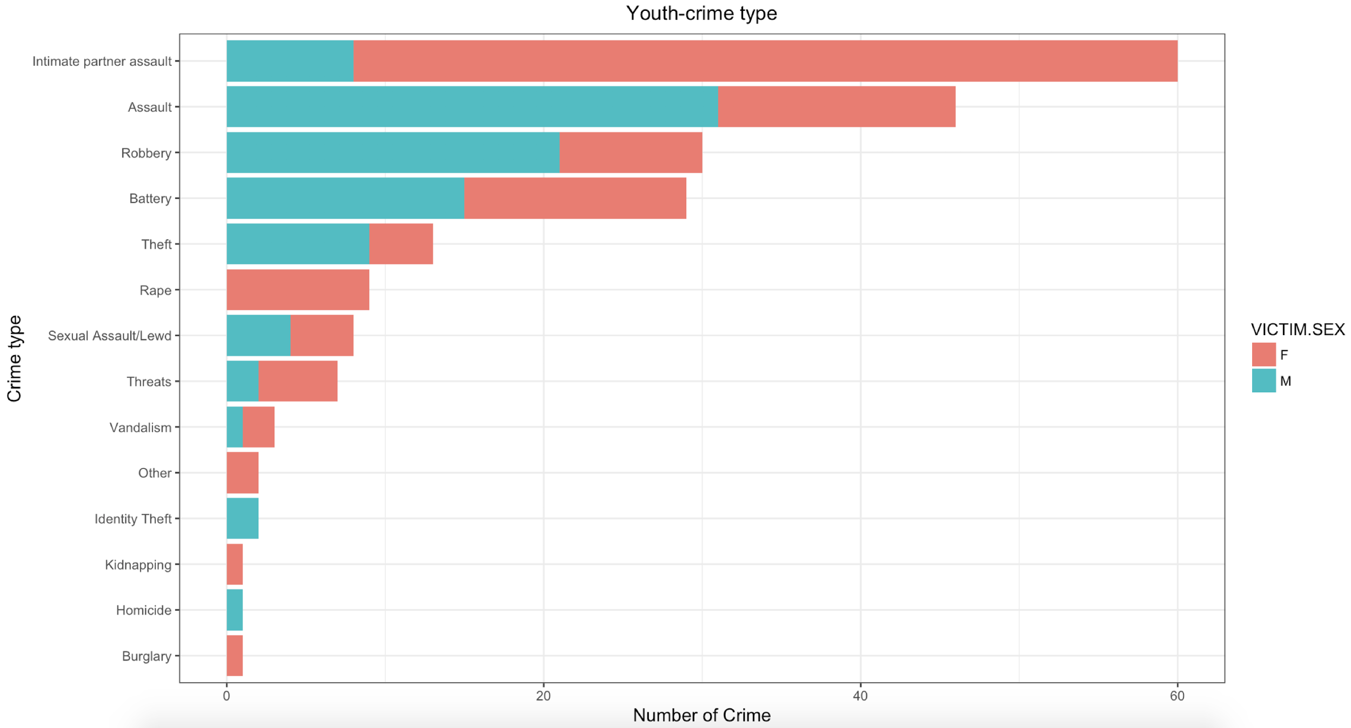

Top 5 crime types in youth crime are intimate partner assault, assault, robbery, battery and theft. However, males and females suffer from different types of crime. For example, females are more vulnerable to intimate partner assault and males are more likely to get involved in Assault with deadly weapon and aggravated assault.

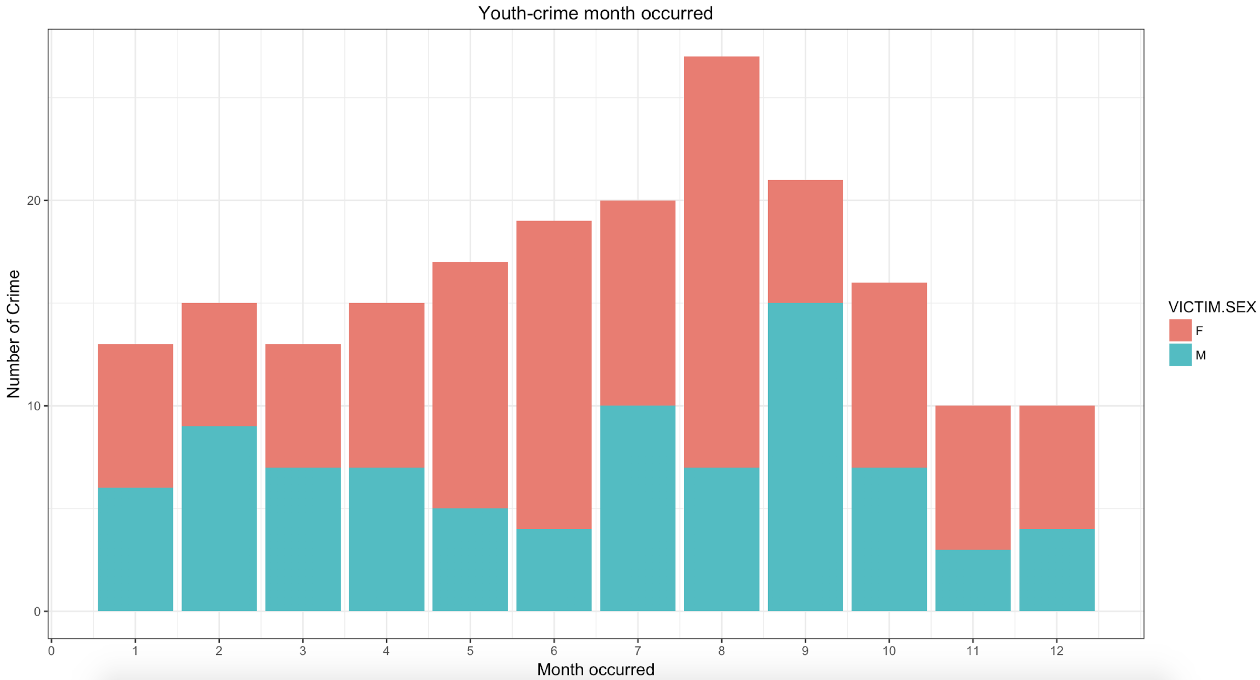

Since the time scale of crime dataset is from August 2016 to August 2017, in order to get distribution throughout 12 months, we choose crime data from January 2017 to August 2017, plus September 2016 to December 2016. Number of youth crime get its highest value in July, August and September. The reason might be the burning hot summer in Los Angeles makes people unhappy and more likely to commit crimes.

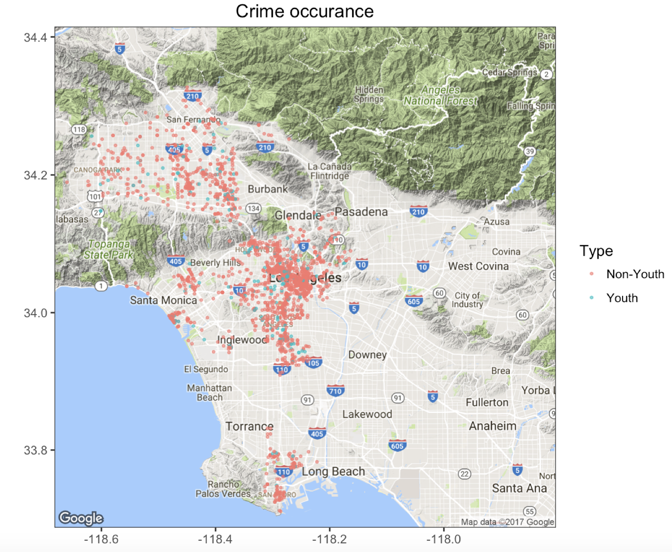

This map shows the area distribution of crime. Blue dots represent youth (18-24) and red dots represent non-youth. Overall, from the chart we can see that the location pattern of crime is almost the same between youth and non-youth.

**Recommendations**

From our previous analysis, youth and female are the most vulnerable population subgroup, so we highlight issues and solutions for youth and female currently homeless in Los Angeles, California. Homelessness takes quite a toll on lives of youth and female homeless people by increasing rate of mental health problem, unemployment, and lower educational attainment. Based on that, we conclude following recommendations.

Employment

Employment is a critical way to help homeless individuals maintain a stable income and get off the streets. Most young people are eager for the opportunity to work, they are full of potential but face significant barriers to employment. We aim to address some of the barriers youth face by cooperating with some non-profit or non-government organizations to assist the unemployed homeless youth, so they can gain financial stability to move into permanent homes.

In more detail, we should help transition-aged youth advance in employment opportunities by providing training program and skill building courses for them. From our research, we recommend LA city to cooperate with non-profit organization such as National Coalition for the Homeless which provides workforce services to help people prepare for employment.

Priority housing placement

Ensuring most vulnerable population to have access to affordable and stable homes is one of the most important steps. Homeless youth face a lot of barriers to stable housing, for example, inadequate income, lack of relationships with supportive adults. We should expand the reach and effectiveness of Transitional Living Programs and give youth and female homeless priority to these housing services since they are of highest needs.

Mental health support

Vulnerable people need a continuum of mental health support to help prevent them from being homeless, and to protect them if they do. As we mentioned before, females are more vulnerable to suffer from domestic violence and sexual assault, so they need more mental support. Youth also need family preservation while young people are still in the home and early intervention for youth who have recently left home. We recommend LA County department of Mental Health provide psychological assistance to those female with mental problem and directly follow up with consulting service.

Post- foster-care youth support

Above recommendations address the critical problems experienced by homeless individuals, and help them transition into a economically sound and emotionally stable lifestyle. Beyond helping the youth and female subgroups, Los Angeles City should also focus support on youth homeless who came from foster care.

As described previously, the largest increase in homeless count was seen among the homeless youth. A big contributor to this increase was the homeless youth who turn 18 and leave foster care. According to the Alliance for Children’s Rights Organization, half of the youth who have aged out of foster care end up homeless or incarcerated.

These homeless are legally adults, but leave without knowledge of basic skills for everyday living, with no job, no income, and little to no educational resources and connections to help ease the transition into adulthood. Unfortunately, these homeless youth have big goals and opportunities, but lack the ability to sustain themselves.

We recommend Los Angeles City to tackle this problem by first, identifying the critical segment of homeless youth who have come from foster care. The city should partner with two non-governmental organizations, Living Advantage, Inc. and The Alliance for Children’s Rights. These organizations hold life skills workshops and academic classes for foster youth. In the partnership, we advise LA City to dedicate funding to these workshops, to ensure top instructors and increase the number of available spots. Further, we highly recommend the city to allocate funding towards transportation to bring these homeless youth to the workshop locations.

These recommendations aim to bridge the non-governmental organizational training with the homeless youth who came from foster care.

**Dashboard**

In this part, we built many interactive graphs based on location and time span.

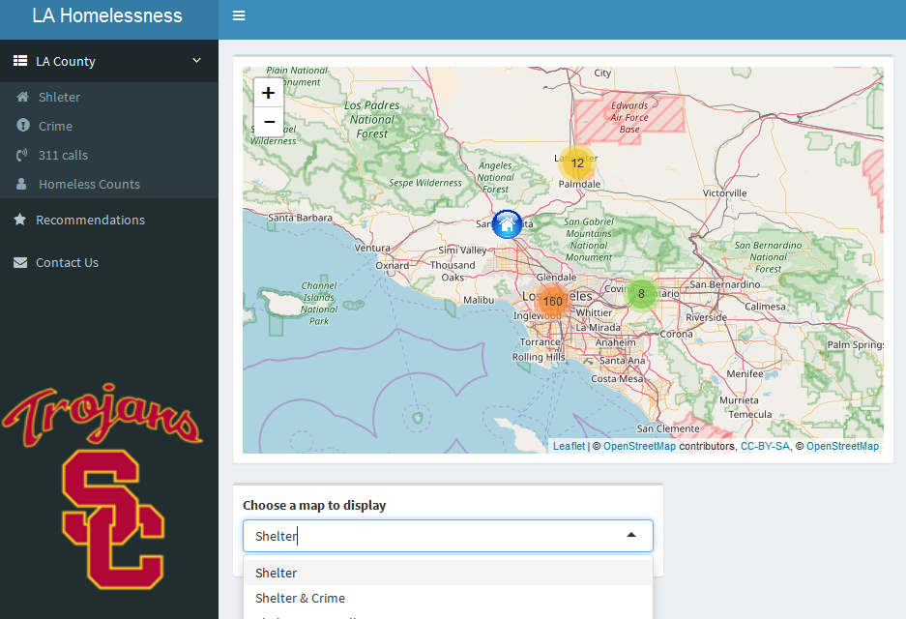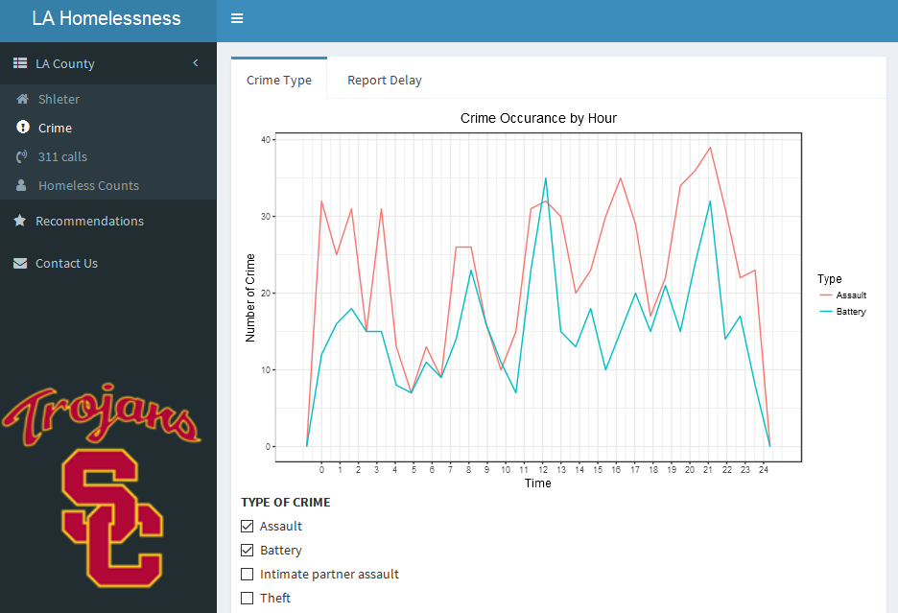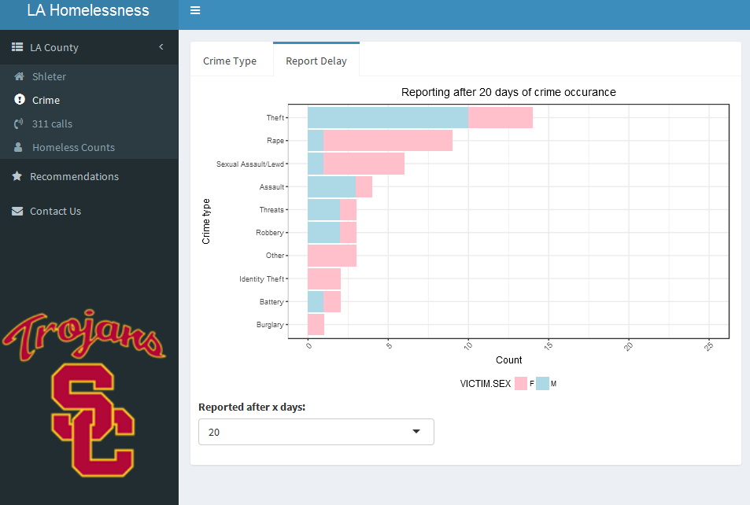

**Shelter**

* In the shelter dataset, we drew some interactive maps using leaflet package to help the City of Los Angeles to gain a straightforward view of Homeless, Crime, 311 calls as well as shelter distribution. In the dropdown menu, you can choose different maps to show.

**Crime**

* In the crime dataset, we made a graph that shows when different types crime occurred throughout the day. There is a check box at the bottom where you can choose the types that you want shown on the graph.
* The other tab shows the report time and you can choose different report days. From this graph, we found that females always take more time to report the rape and sexual assault crime than males. This demonstrates that females are reluctant to report this kind of crime.

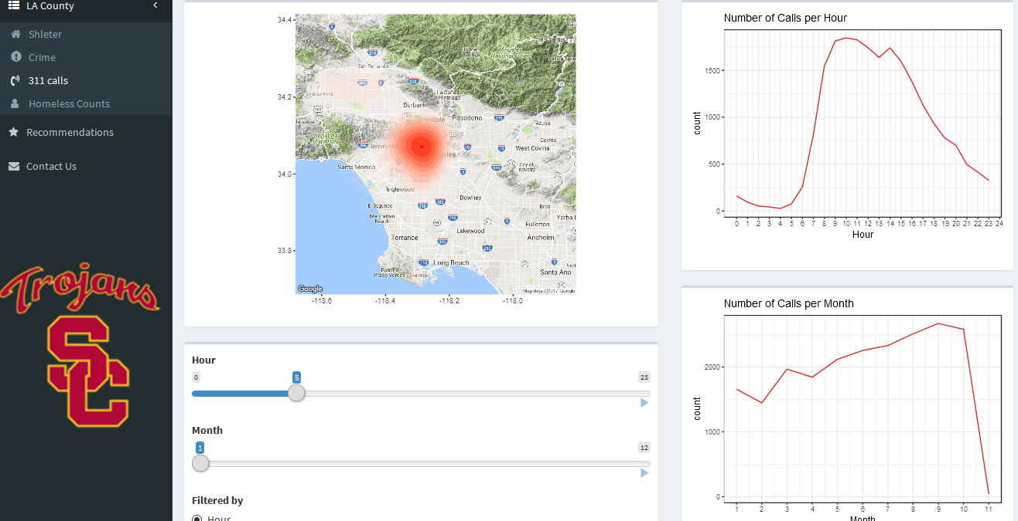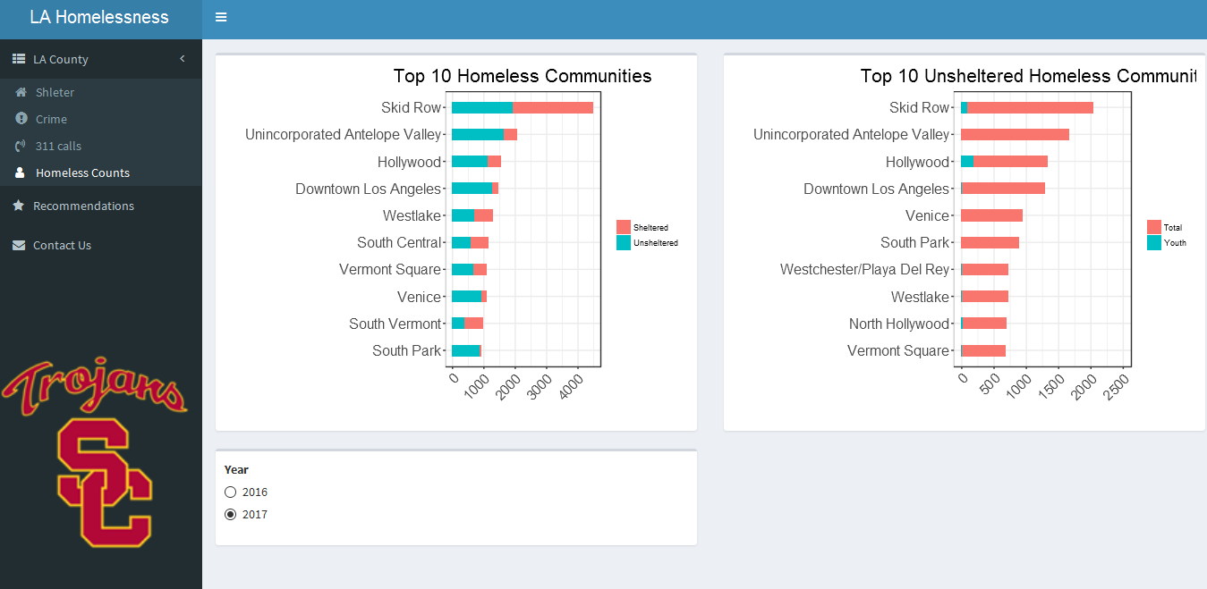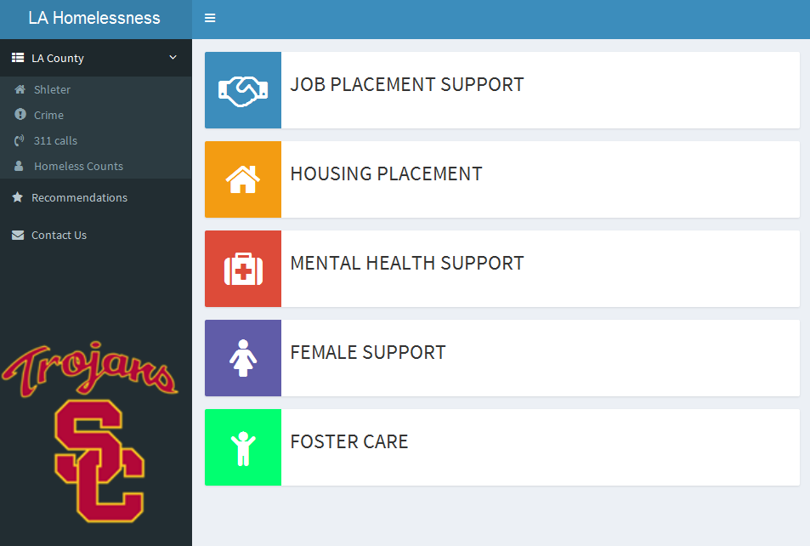

**311 calls**

* We wanted to give the user the ability to customize time and visualize changes over time. In the 311 calls and homeless count datasets. we draw many graphs based on the time span.
* The picture in the 311 calls dataset represents the change of 311 calls. You can choose to filter by hour or month, and then you can drag the slider to figure out the change. What’s more, If you want to view the change continuously, you can click on the triangle button. Which will show you an animation. From this picture, we can infer that most 311-calls occured in October around 9-11am.

**Homeless Count**

* In the homeless count, we made a graph that contains the top 10 communities which have the most homeless and unsheltered homeless. As we can see, the Skid Row has the most total homeless as well as the most unsheltered homeless. However, the Hollywood has the most youth homeless. We made an assumption to explain it; that is, the youth come to Hollywood with a dream to be a star. But if they fail, most of them are unable to afford the high Los Angeles housing prices and becomes homeless. Thus, government should pay more attention to these two communities

**Recommendation**

* We also put our recommendations in our dashboard. You can click on each of them and then the relevant website will be opened in your browser. What’s more, if you want to search more information, you can click on the “Contact Us” button, which will take you to the LA city Website